Template – Student Course Registration Sequence
The template named “Template – Student Course Registration” is applicable to Anthology Student.

Purpose and Outcome
This template provides a form sequence and supporting workflow for a form sequence to be completed by an enrolled student to register into the first-class section found for a given course and term.
The top section of the registration form is auto-filled based on the student’s login. The student then selects the program, course(s) , and term. This sequence will create a Registration from the document record.
The sequence requires the following:
- A complete Student record must exist in the Anthology Student database.
- The student must have a Portal login to log into this authenticated sequence.
Upon completion of the sequence, the workflow creates a PDF of the form sequence and inserts the PDF into the Anthology Student Document Center.

Prerequisites
The template was built with Forms Builder using the applications listed below. The template is forward compatible with later versions of the listed applications.
Application | Compatibility Version
Forms Builder Designer and Renderer | Compatibility Matrix
Web Client for Anthology Student
Workflow Composer
Packages installed from Package Manager in Workflow Composer | Activities and Contracts (V2)  Contracts (V1)  Forms Builder Contracts  Note: Ensure that the Forms Builder Contracts package used in Workflow Composer is aligned with the version used in the Forms Builder. Additionally, confirm that both Activities and Contracts (V1) and Activities and Contracts (V2) packages in Workflow Composer match the versions used in the Student Web Client to avoid compatibility issues.  It depends on which product is being used, for example:  For CRM:  Activities And Contracts (CRM)  Forms Builder Contracts
Workflow Tracking Database | N/A
Staff STS | 3.3.x

Step 1: Download and Import the Template
- Download the template file to your environment (local drive or network location).
- Log into Forms Builder Designer.
- Click the Export/Import tile.
- Select the Import tab.
- Click Select exported file and navigate to the downloaded template file.
- Click Import.
Note: Import may fail if same files name is already available in environment or overwrite option.

- Export/Import
The following forms will be imported:
- Student Course Registration Form
- Default-Confirmation

Step 2: In Form Designer…
- From the Forms slide out, select the Student Course Registration Form.
- Customize the form for your environment. Modify properties on fields/components to make them required, etc., or add/remove fields on form.
Make sure you edit the text in the Labels and other controls as applicable for your institution.
- Fields and Components
- Save the form.
- Repeat steps 1-3 for the Default-Confirmation form as appropriate for your institution.

Step 3: In Sequence Designer…
- Locate the Student Course Registration Sequence in the Sequences pane.
- Click Save As to create a copy of the sequence/workflow and customize the copy for your use. This way you can always refer to the original sequence/workflow you downloaded.
- Optional - Add a custom style (theme) associated with your campus.
- Themes
- Select your saved sequence in the Sequences pane.
- In the Properties Pane, select End State Form “Default-Confirmation”.
- Save the sequence.

Step 4: In Workflow Composer…
- Open the workflow for your saved sequence.
- Open the Workflow for a Sequence
- Explore the arguments, states, and transitions to get an understanding of the workflow logic.
- In the “Submit” transition before the “End” state, expand the Add to Doc Center sequence.
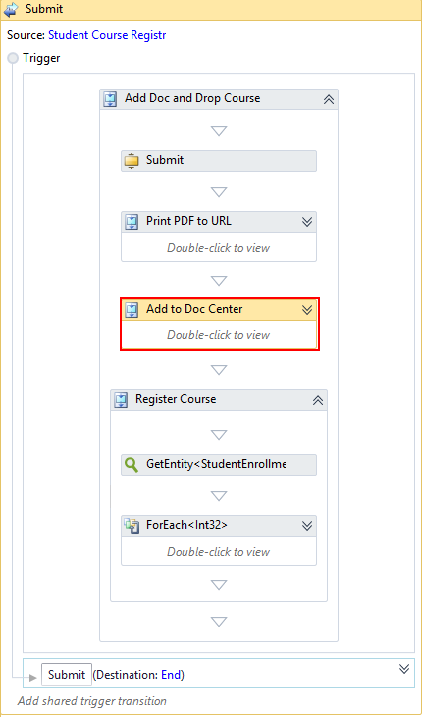

- In the CreateDocument activity, select Document Type and Document Status values appropriate for your environment and use case.
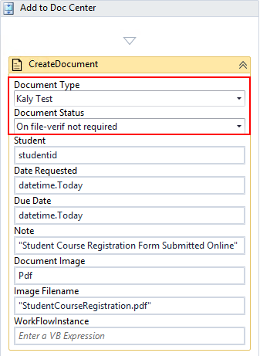
The LookupClassSections activity further down in the Submit transition will register the student into the first class section found for the given course and term and the StudentCourseRegistration.pdf file will be added to the student’s documents.
- Save and Publish your workflow.

Step 5: In Forms Renderer…
Select your sequence and try it out!
- Sequence List
- Find your Student Course Registration Sequence and copy the URL to the clipboard.
- Paste the URL into a browser and complete the form sequence.
- In Anthology Student, verify that the student is registered and the registration documents is saved as specified in the form sequence.

Step 6: Lastly…
Once your updated sequence has been tested successfully, it is recommended that you disable the workflow for the original Template version.
- In Workflow Composer, in the Server section of the ribbon, click Open.
- Find the workflow named Student Course Registration Sequence.
- Clear the Enabled check box and click Save.

